Be Outside Idaho
Idaho Recreation and Tourism Initiative
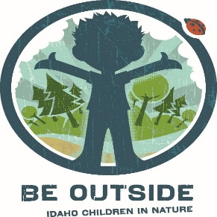

FOR IMMEDIATE RELEASE

Date: October 9, 2019
Contact: Vicky Runnoe, IRTI Grant Reviewer
208-287-2902 | victoria.runnoe@idfg.idaho.gov

WINNERS OF THE BE OUTSIDE IDAHO 2019-2020 GRANT CYCLE HAVE BEEN RELEASED

BOISE (October 9, 2019)—The Idaho Recreation and Tourism Initiative (IRTI) is a partnership among state, federal, and non-profits that share resources to support collaborative projects in Idaho communities and schools statewide.

Be Outside Idaho is a grant program supported by IRTI alongside additional statewide partners. For years, Be Outside Idaho has helped facilitate the growth and creation of outdoor education programs that connect children with nature in Idaho, from backyards to mountaintops.

This year, Be Outside Idaho was able to fully fund or partially fund eleven out of 26 total projects. With so many unique and inspiring applications this year, the grant committee found it difficult to decide and would like to encourage everyone to try again in the 2020-2021 grant cycle.

This year’s funded projects included:

Organization | Project
Anser Charter School | The Anser Charter School Bicycle Project
Butte County Soil and Water Conservation District | Natural Resources Tour & Stewardship Week
Canyon County Parks | Canoe Science Camps at Lake Lowell
The City of Kuna | Be Outside Kuna
Golden Eagle Audubon | Binoculars for Audubon Society Programming
Gooding Public Library District | Learning in our Backyard
Kendrick School District | Growing Our Own at Juliaetta Elementary School
Meridian Middle School | MMS Ambassador Leadership Camp
Meridian Parks and Recreation | Unplug and Be Outside Week
Palouse Land Trust | Unplug and Be Outside Week Moscow
Post Falls School District | Coeur d’Alene Lake Eagle Watching Trip

The total funded amount this year was $13,000.

For more information about IRTI and Be Outside Idaho, visit beoutsideidaho.gov.
###

